SEL 703 – Internship Engineering

SmartHealth Band
A Wearable Sensor System with On-Device Analytics and Web Dashboard for Everyday and Health Monitoring

Overview:
This project develops a low-power wearable device that continuously monitors basic physiological and activity signals such as heart rate and steps, and transmits them to a web-based dashboard. Lightweight algorithms or ML models will run on the device and/or backend to derive higher-level health indicators (e.g., stress level, activity intensity, adherence to movement goals). The system is designed for both everyday users and patients, providing a generic but extendable platform for health and wellbeing monitoring.

Background / Problem
Instead of sporadic clinic visits, modern lifestyles and chronic health issues (such as cardiovascular risk, sedentary behavior, and stress) necessitate ongoing, inconspicuous monitoring. There are a lot of commercial wearables available, but they are frequently closed ecosystems, have limited customization options, and are difficult to incorporate into clinical or research processes. A versatile, open, and inexpensive wearable platform that can gather multi-modal physiological and activity data, apply lightweight algorithms or machine learning models, and display trends on a web dashboard for both general users and patients under supervision is required.

AIM
The objective of this project is to design, implement, and assess a microcontroller-based wearable health monitoring system that can reliably transmit the processed data to a cloud-connected web dashboard, perform on-device preprocessing and analytics, and track fundamental signals like heart rate, step count, movement, and basic derived metrics. In addition to being appropriate for use as a data source in clinical or research settings, the system should be sufficiently general for tracking daily wellness.

Block Diagram
[Sensors] → [Wearable Microcontroller + Edge Processing] → [Wireless Link] → [Gateway Device] → [Backend Server + Database + ML] → [Web Dashboard] → [User / Clinician]

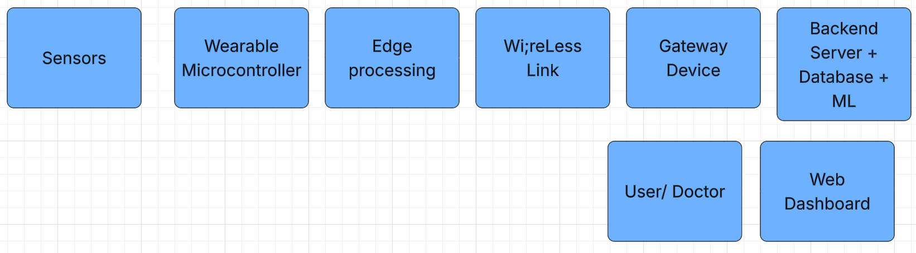

For Alzheimer’s patients:

